**04/10/2021 ML LAB 5 2019103573**

**SINGLE LAYER PERCEPTRON**

**AND PROBLEM**

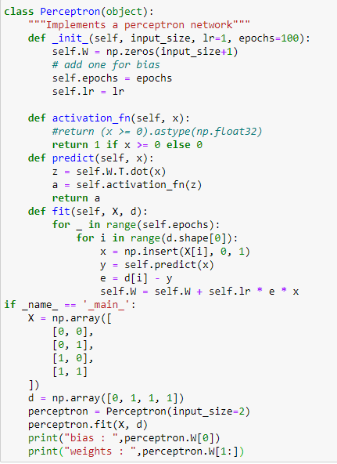**CODE :-**

**OUTPUT :-**

**OR PROBLEM**

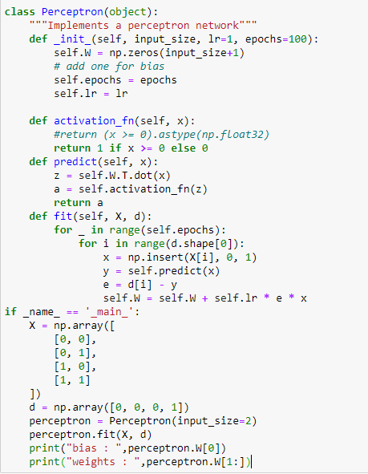**CODE :-**

**OUTPUT :-**

**XOR PROBLEM**

Perceptrons can only solve linearly separable problems. In the real world, however, many problems are actually linearly separable. For example, we can use a perceptron to mimic an AND or OR gate. However, since XOR is not linearly separable, we can’t use single-layer perceptrons to create an XOR gate.